Char Flow Auto Gen Tool User Manual

Version 1.0.0

ADC Software Team
Teradyne, Inc
2015 06
LIMITED REPRODUCTION RIGHTS
For Teradyne, Inc Customers
Use, reproduction or distribution of this document is restricted to Teradyne, Inc customers
solely for internal use by the Customer's employees whose responsibilities include Teradyne, Inc. equipment.
CREDITS AND TRADEMARKS
IG-XL™ is a trademark of Teradyne, Inc.
Magnum™ is a trademark Teradyne, Inc.
All other trademarks belong to their respective owners.
The material in this document is subject to change without notice. Teradyne, Inc assumes no
responsibility for any errors which may be contained in this document.
ADC Software team
Teradyne, Inc
2F, Building 10, 1201 Gui Qiao Road,
Jin Qiao Export Processing Zone,
Pudong, shanghai China 201206
86.21.38424668

Contents
Contents 1
1. Introduction 1
1.1 About Char Flow Auto Gen Tool 1
1.1.1 Char Flow Auto Gen Tool - Brief Introduction 1
1.2 Prerequisite 1
1.2.1 MS Office 2003+ 1
1.2.2 IG-XL All Version 1
1.3 Feature List 1
2. Installation 2
2.1 How to Import 2
2.1.1 Locate your VBA project, choose "Import File". 2
2.1.2 Import forms and modules 2
2.1.3 Result 3
2.2 How to Run 3
2.2.1 Open Immediate Window 3
2.2.2 Run command 4
2.2.3 Result 5
2.3 How to Read Config 5
2.3.1 Click "LoadConfig" button 6
2.3.2 Choose Config file 6
2.4 How to Delete 7
3. Quick Start 9
3.1 User Operation Guide Line 9
3.2 Click "Search" button 10
3.3 Function/Flow/Instance - brief introduction 11
3.3.1 Function block 11
3.3.2 Flow block 13
3.3.3 Instance block 14
3.3.4 Instance/Flow Options block 16
3.3.5 Result 17
3.4 Test Item settings brief introduction 17
3.4.1 Search out all Test Items 17
3.4.2 Select the Test Items 19
3.4.3 Confirm window 20
3.4.4 Result 24
4. Format Introduction of Tool Configs 25
4.1Functions column 25
4.2 Converted Head and Converted End columns 26
4.3 DC_Specs/Category column 27
4.4 Arguments(arg0 - arg15) columns 28
5. Function Description 29
5.1 ToolConfig_FrmMain 29
5.2 ToolConfig_FrmConfirm 31

Introduction
This chapter will give you an outline introduction of Char Flow Auto Gen Tool.

1.1 About Char Flow Auto Gen Tool
In this section, user will get a brief idea of what Char Flow Auto Gen Tool is and how this tool can increase user's working efficiency .

1.1.1 Char Flow Auto Gen Tool - Brief Introduction
Char Flow Auto Gen Tool is a tool to change the "Function Name" which corresponding to the "Parameter" in "Flow Table Sheet" in batch mode.
To auto-generate corresponding Shmoo, Pin Margin, Vmin, Vmax Flow based on specified Test Flow and Instance data.

1.2 Prerequisite

1.2.1 MS Office 2003+
Microsoft Office is required and must needed when use this Char Flow Auto Gen Tool.

1.2.2 IG-XL All Version
Any version of IG-XL is not required here. Besides, user should know that Char Flow Auto Gen Tool cannot running along with IG-XL at any time.

1.3 Feature List
- Support to let user select any Flow or Instance sheets from current workbook.
- Support to auto-scan Flow data from user's selection.
- Support to let user select VBT functions which Instance will called, VBT functions will offered as VBT Module.
- Tool 可选是添加 Flow 内容或者替代 Flow内容,可选是添加instance 内容或者替代instance内容.
- Support to auto-generate Test Instance sheet and Flow sheet.
- Support to auto-follow the arguments format of raw instance, and auto-fill some default value.
- Support to auto-generate Job sheet, and glob specs can follow the format from specified job.
- Support to change the number of functions and input parameters.

Installation
This chapter will show user how to import, run and delete modules by using Char Flow Auto Gen Tool.

2.1 How to Import

This section will show you how to import modules and forms which will be used by Char Flow Auto Gen Tool.

2.1.1 Locate your VBA project, choose "Import File".
Right click the VBA project, choose "Import File".
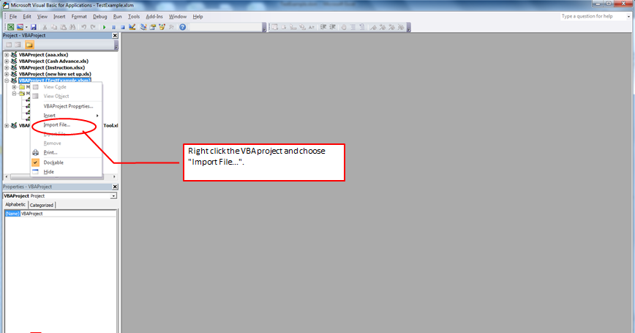

2.1.2 Import forms and modules
Import two forms (ToolConfig_FrmConfirm.frm,ToolConfig_FrmMain.frm)
and one module (ToolConfig_ModuleRun.bas)

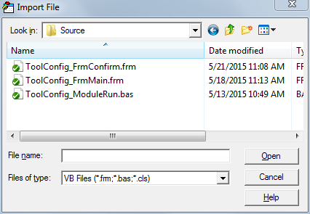

2.1.3 Result
Two forms and one module are all now been imported into project now.

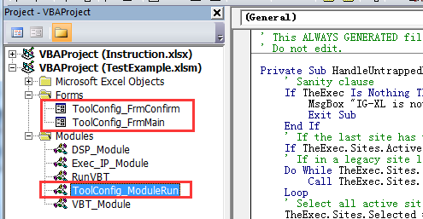

2.2 How to Run

This section will show user how to run Char Flow Auto Gen Tool.

2.2.1 Open Immediate Window
Click "View" item in Menu bar, and then choose "Immediate Window" to run program.
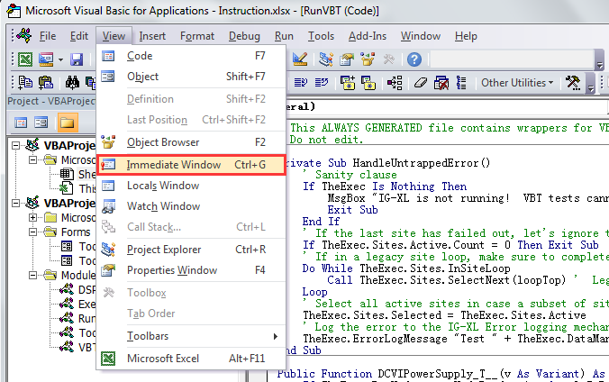
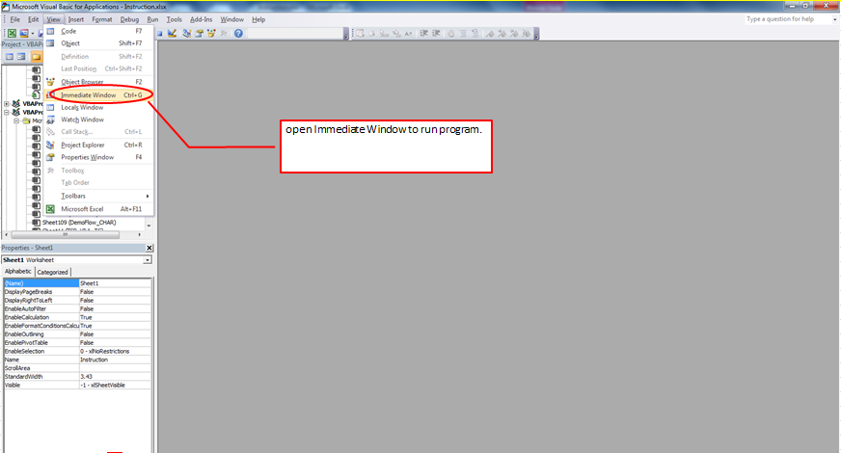

2.2.2 Run command
In immediate window, please input the command line as "RunTest", and then press Enter key.
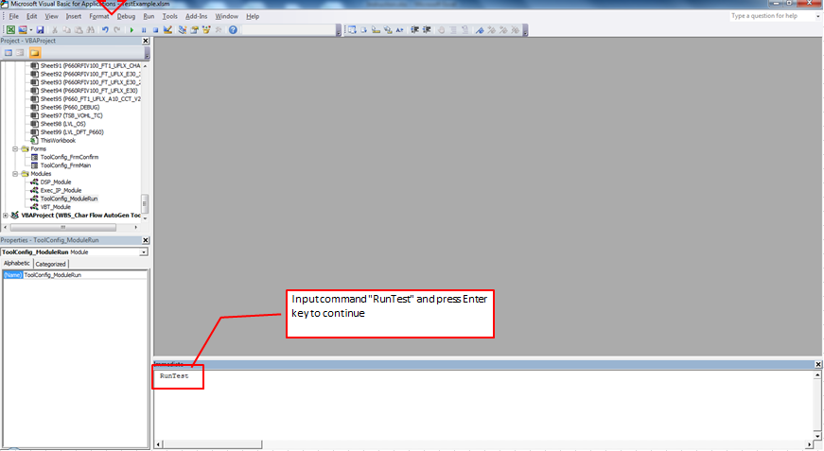

2.2.3 Result
A ToolSetup UI will shown up after you press Enter key with the right input of command "RunTest".
Note: the "Search" button after the "LoadConfig" is not enable for this time, it will be enable after the your loading step is done.
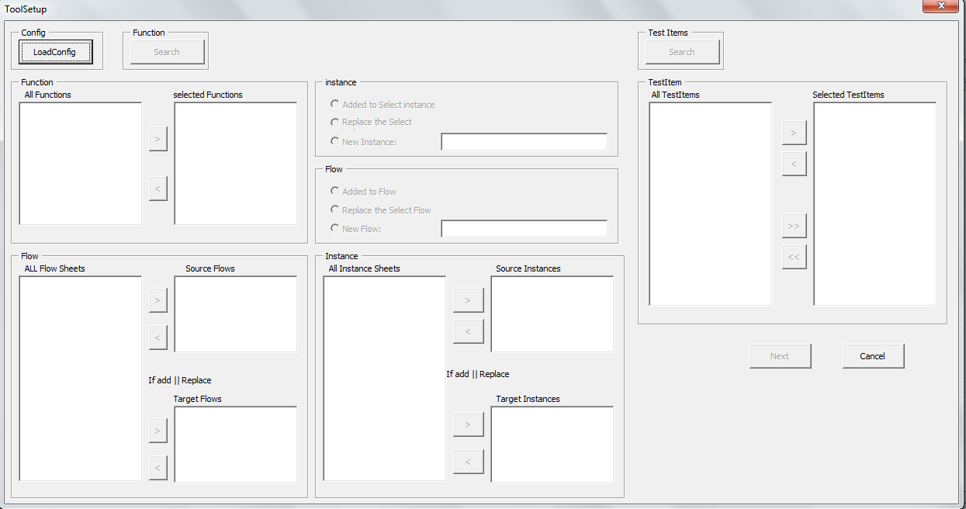

2.3 How to Read Config
In this section, user will know how to read config file into Char Flow Auto Gen Tool.

2.3.1 Click "LoadConfig" button
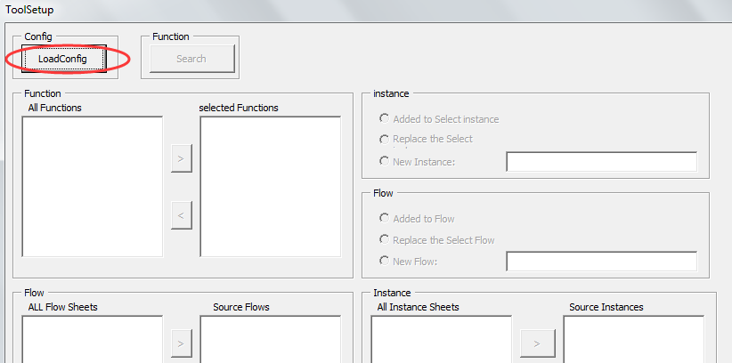

2.3.2 Choose Config file
Choose the config file which you want to load into the tool
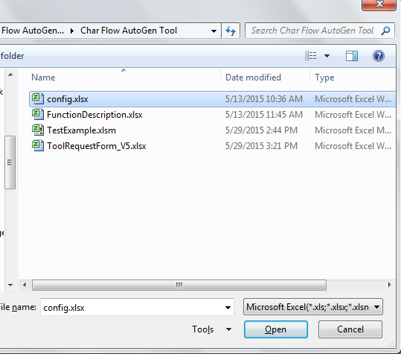

After the loading is done, a window will pop up to show that you have finished this step.
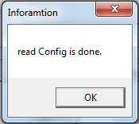
And now if you switch to ToolConfig sheet, you can see new Tool Config data already been imported into the sheet.
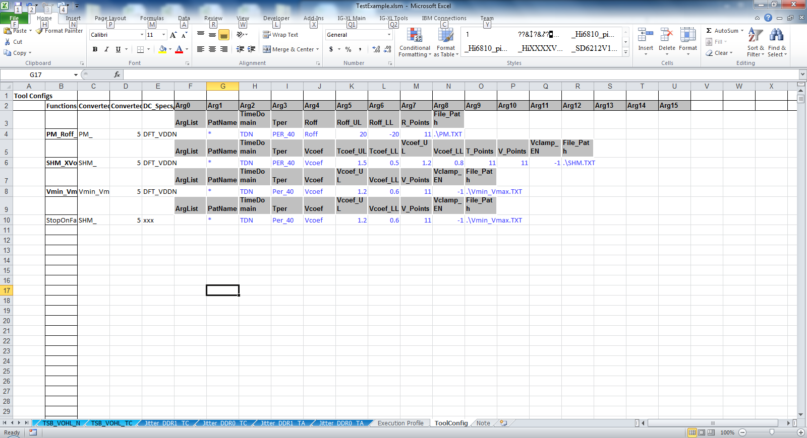

2.4 How to Delete
If you want to delete those forms or modules which been imported in previously step, you can right click the specified form name or module name to choose "Remove" option.
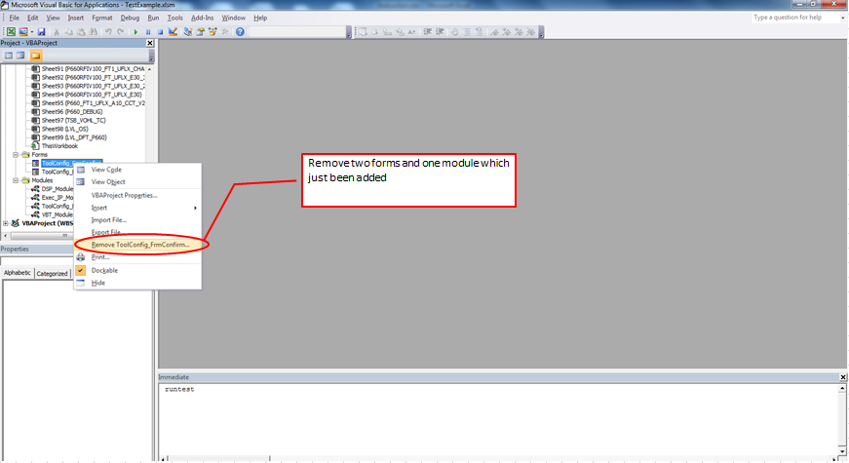

3. Quick Start
This chapter will show you the way of how to properly use Char Flow Auto Gen Tool.

3.1 User Operation Guide Line
Please follow the guide line below to use the ToolSetup UI, four red arrows with sequence number can show you the sequence of each operation.
(from left to right, from up to down)
Function -> instance/flow options -> Flow -> Instance -> Test Items -> TestItem -> Next
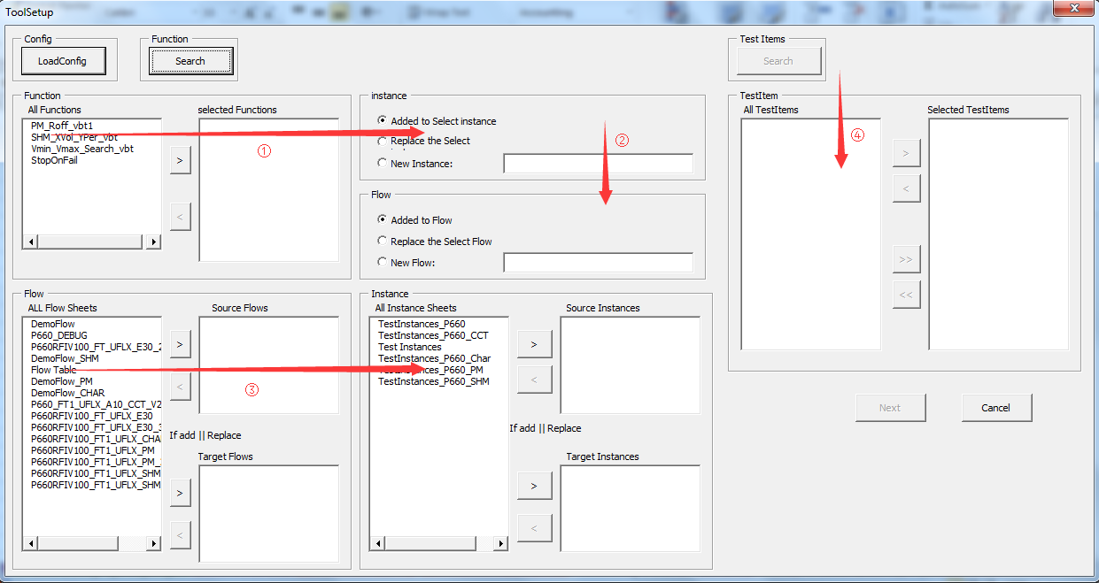

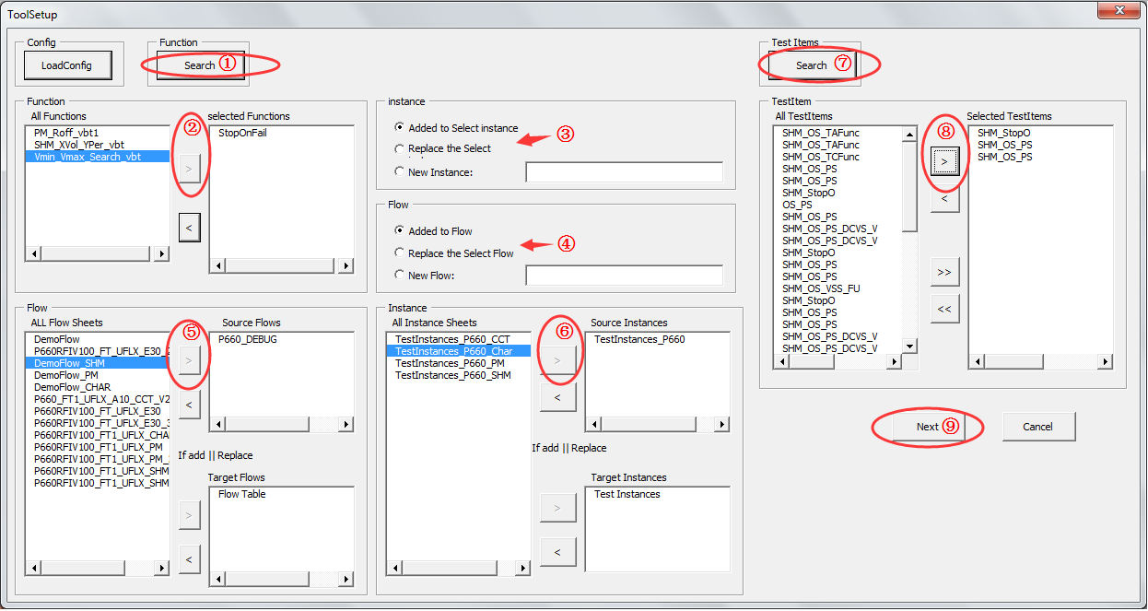
Sample of how to use this tool:

1) Click Search button to get all available information from IG-XL workbook
2) Choose the Function name you want
3) Choose the result type of how the Instances will be stored.
4) Choose the result type of how the Flow will be stored.
5) Choose the source and target Flow sheets.
6) Choose the source and target Instance sheets.
7) Click Search button to take out all Test Items from current workbook
8) Select the Test Items you want to modified in next step
9) Click Next button to continue

Upon introduction is just a sample, you can refer next few sections for detailed using method.

3.2 Click "Search" button
As you can see, "Search" button is now available for user to click.
Click "Search" button to continue.
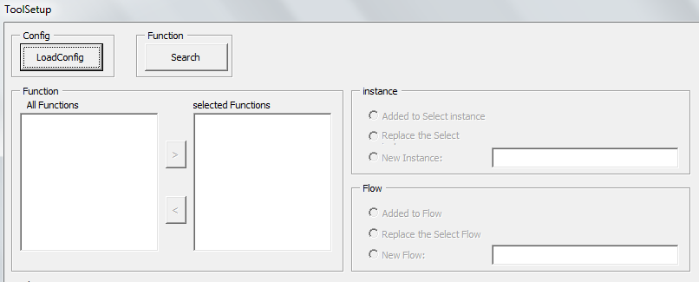
As you can see in below picture, after you click the Search button, Function/Flow/Instance will list all available items for you to choose.
Please refer next chapter for further details about these three parts.
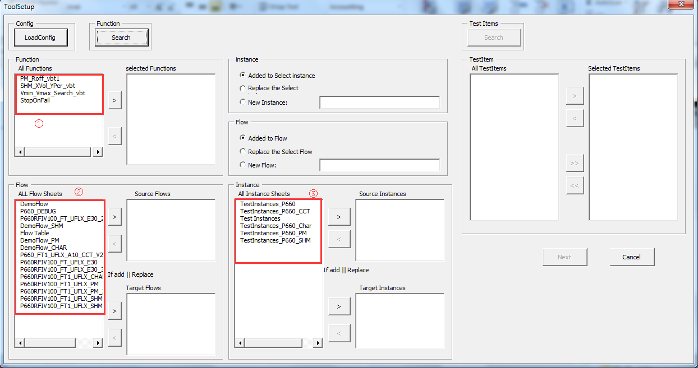

3.3 Function/Flow/Instance - brief introduction
After your correct loading of config file, all Function/Flow/Instance information can be read from Excel workbook to ToolSetup UI.
Below sections will show you what these information mean to users, and give you the path of how these data flow through the context.

3.3.1 Function block
1) As below, All Functions be shown on left side of the Function field, and wait for your next operation.
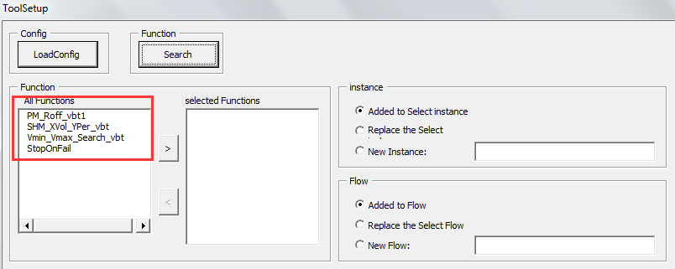

2) Please click the button to choose the Function which you want to use in this part and transfer that function name to right side.
Note: only one function name can be selected and transferred to right side.
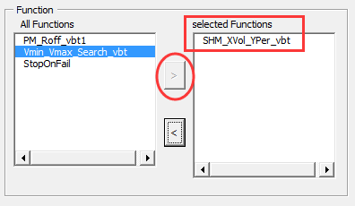

3) The list with all functions on the left side is read from ToolConfig worksheet which you just loaded in section 2.3.
You can see below picture for more details.
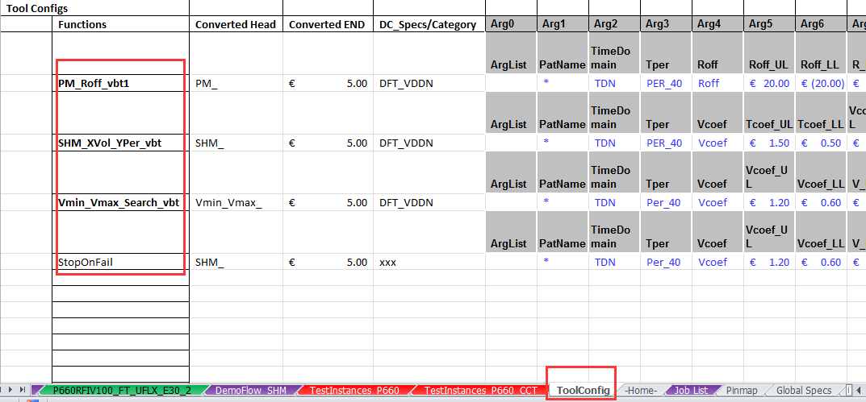

3.3.2 Flow block
1) All flow sheets shown on the left side of Flow block, and waiting for your next operation.
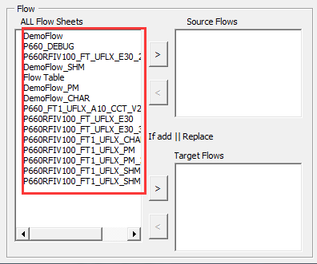

2) Please click the button to choose the Flow Sheet which you want to use in this part for source/target Flows and transfer that Flows name to right side.
Note: only one flow name can be selected and transferred to the right side.

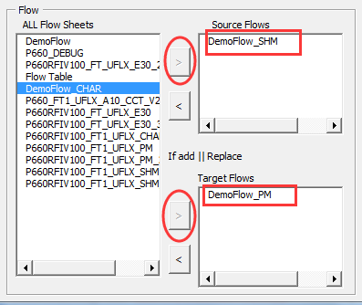

3) The list with All Flow Sheets on the left side is read from all FlowTable sheets in your workbook.
Note: all FlowTable sheets are both started with a string like "DTFlowtableSheet" in cell "A1".
As you can see, all worksheets been marked as FlowTable can be listed in Flow block.
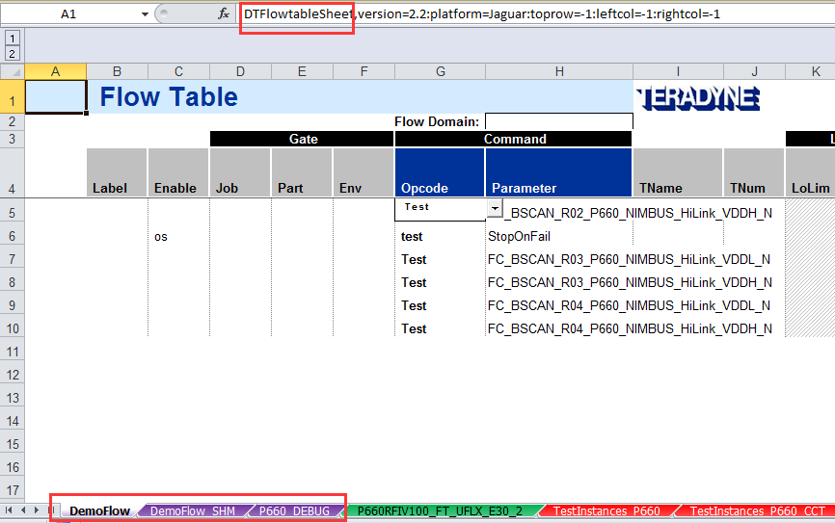

3.3.3 Instance block
1) All flow sheets shown on the left side of Instance block, and waiting for your next operation.

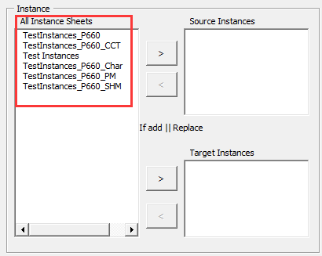

2) Please click the button to choose the Instance Sheet which you want to use in this part for source/target Instance and transfer that Instance name to right side.
Note: only one instance name can be selected and transferred to the right side.
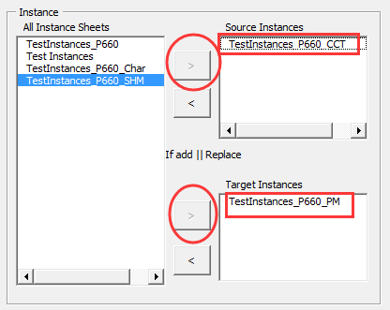

3) The list with All Instance Sheets on the left side is read from all Test Instances sheets in your workbook.
Note: all Test Instances sheets are both started with a string like "DTTestInstancesSheet" in cell "A1".
As you can see, all worksheets been marked as Test Instances can be listed in Instance block.
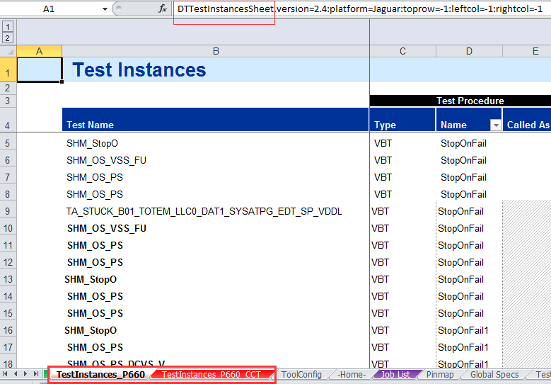

3.3.4 Instance/Flow Options block
User can have three options to choose to affect the position where all changed result information can be stored.
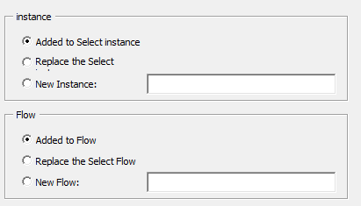

1) Add the result info to the end of current instance/flow sheet you just select.
2) Replace all the info in current instance/flow sheet you just select with the new changed information.
3) Create a new instance/flow sheet to store the new changed information, you need to specify a name for that new created instance/flow sheet.

3.3.5 Result
Below picture shows you a result of all preset is done.
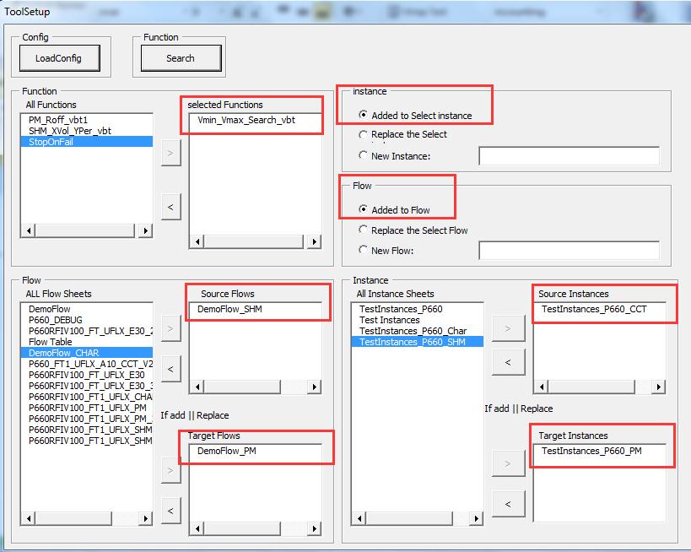

3.4 Test Item settings brief introduction
In this section, user will know how all Test Items been taken out and what affects these settings will make to final result.

3.4.1 Search out all Test Items
1) Click "Search" button, all Test Items will list in All TestItems block.

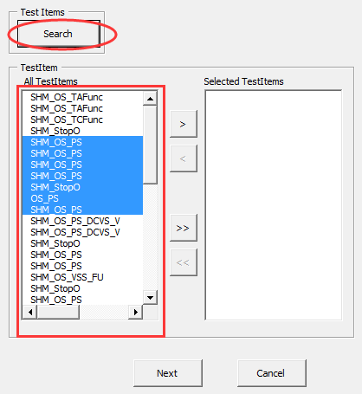

2) The list with All TestItems on the left side is read from all Flow Table sheets and Test Instances sheets in your workbook.
Note: the parameter names in Flow Table sheet are corresponding to the Test Name in Test Instance sheet.
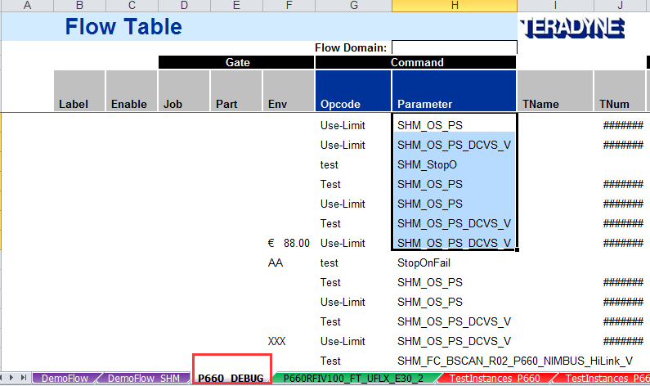

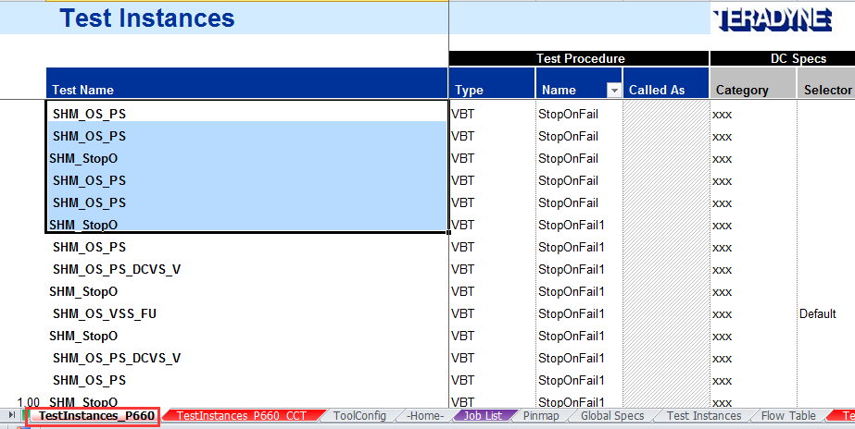

3.4.2 Select the Test Items
1) Select the Test Items which you want to change the name by multi choose the test name on the left side, click the button to next step.
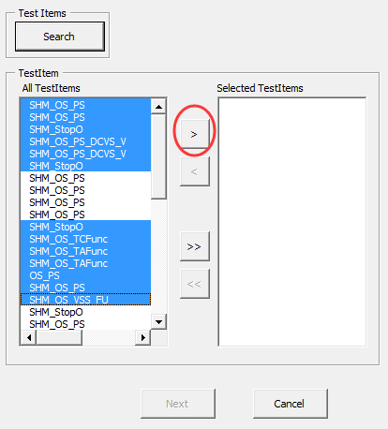

2) After you click the right button, all TestItems be transferred to right side Selected TestItems block and "Next" button been enabled for first time.
Click "Next" button to continue.
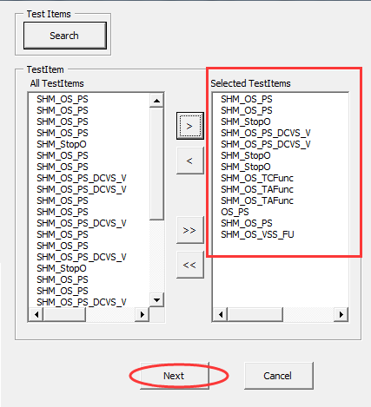

3.4.3 Confirm window
After you click the "Next" button on last step, a pop up window named "Confirm" will show up to you.

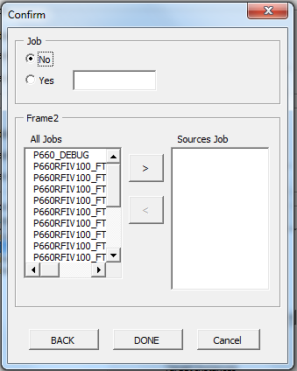

1) No option
No option means set no format change to final result.
Just click "Done" button to make all settings be written to workbook.
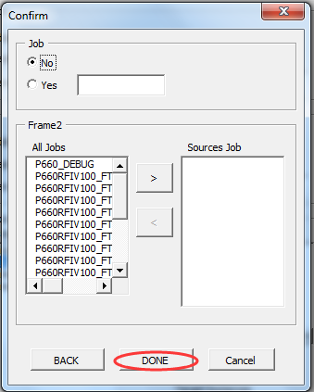

"Processing is complete!" information window will pop up to tell you that all processing is done.
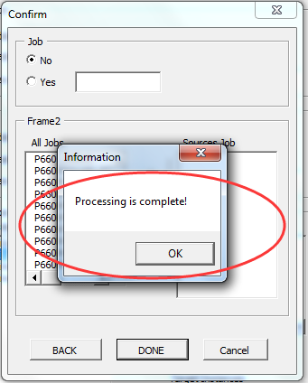

2) Yes option
Please choose the "Yes" option and input the new Job name.

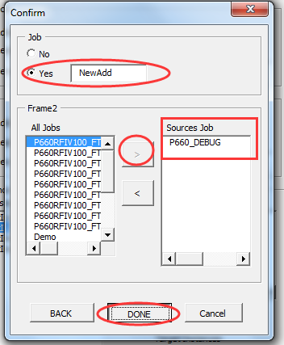

After a while of background operation, all changes will be done.

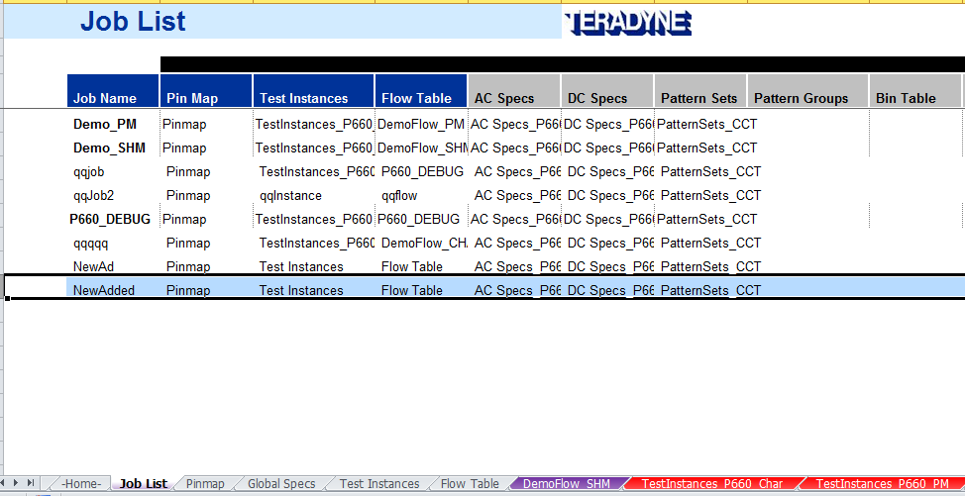

The difference between two options is that "Yes" option will write some changes to the Job List sheet.

3.4.4 Result
All these steps can affect the result of workbook, all changes can be included as three parts:

1) new created Flow Table sheet
2) new created Test Instance sheet
3) new changed Job List sheet.

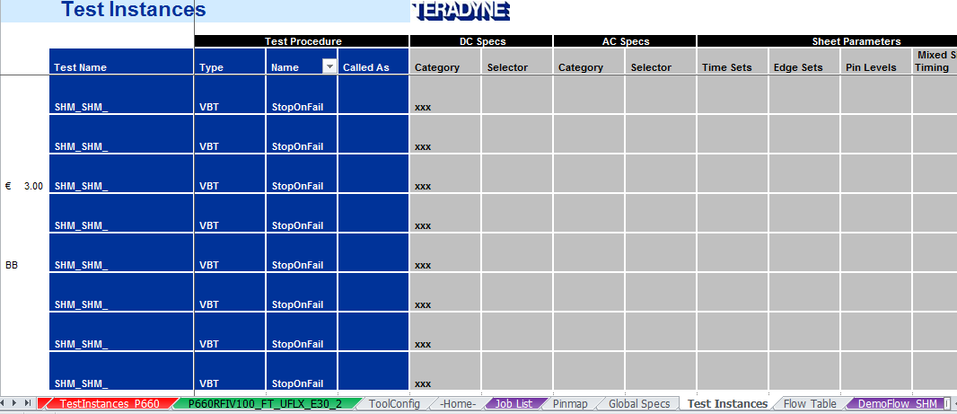

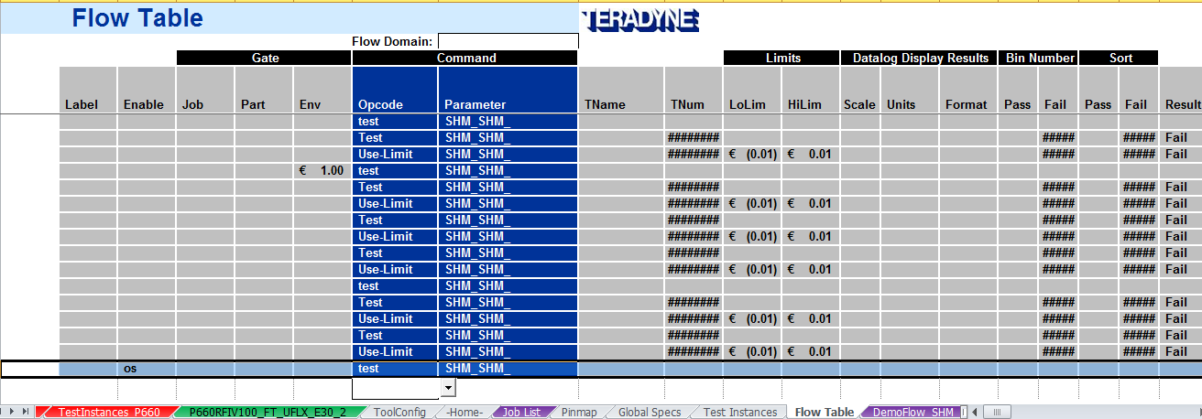

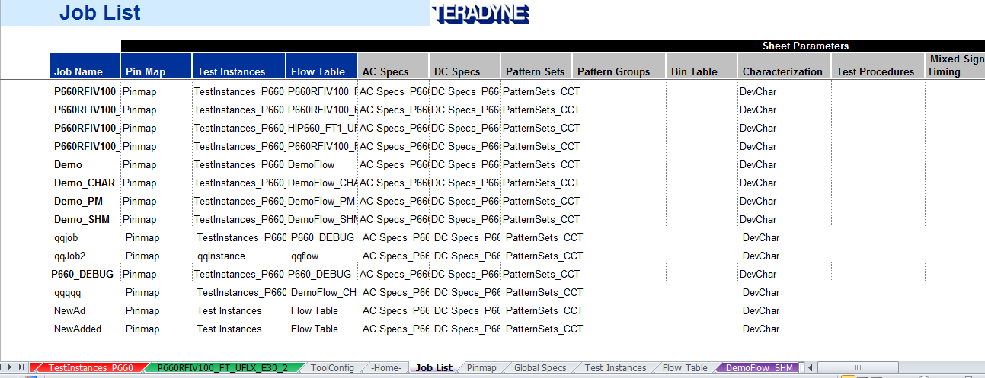

4. Format Introduction of Tool Configs
This chapter will give user an introduction of how the final changes been made to worksheets.
Below picture is an outline of tool config file, we will explain the details in later sections.
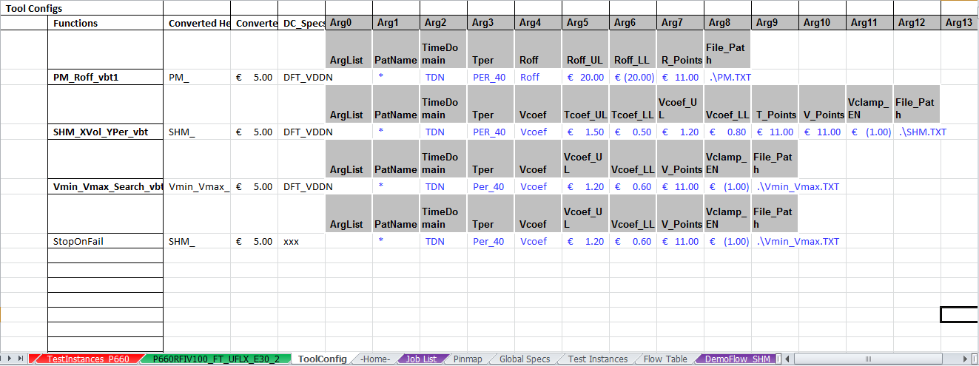

4.1Functions column

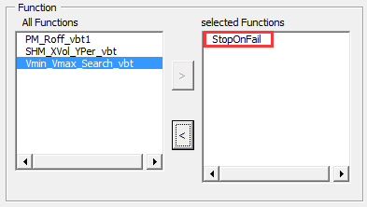

The selected Functions name in section 3.3.1 will be replaced to column Name of Test Instances sheet.

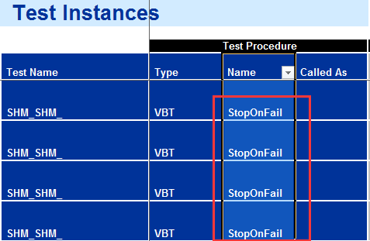

4.2 Converted Head and Converted End columns
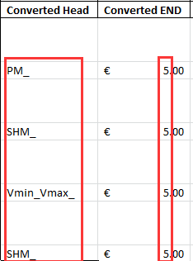
The converted head string will added to the head of each row of Test Name in Test Instances sheet and each row of Parameter in Flow Table sheet.
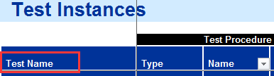
The converted end value indicate the index value that how many letters or digits can be removed before the end of specific TestName.
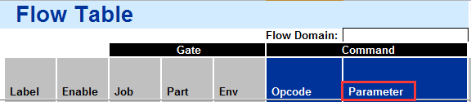

4.3 DC_Specs/Category column

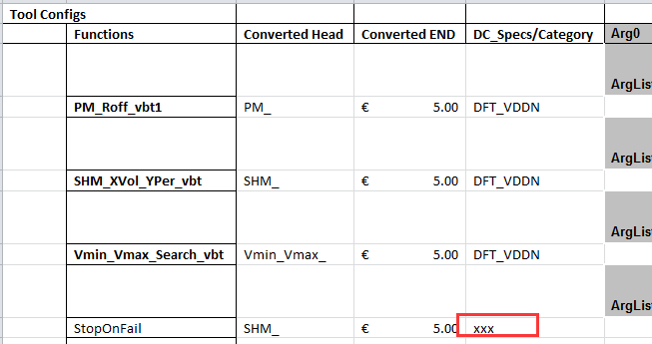

DC_Specs Category in Test Instances sheet will be replaced by the new value.
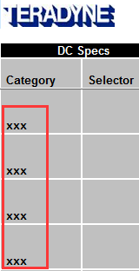

4.4 Arguments(arg0 - arg15) columns

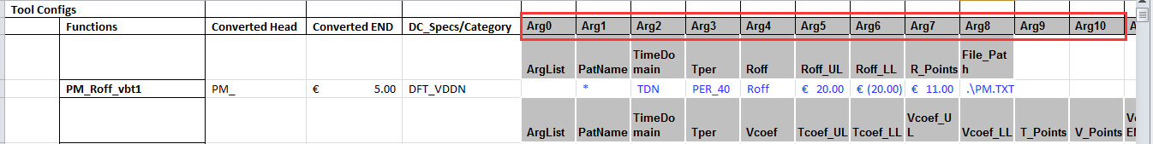
Value arg0-arg15 in Test Instances sheet will be replaced by the new value read from Toolconfig sheet.
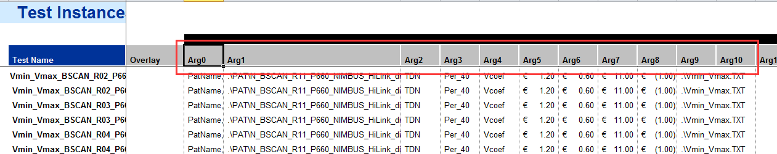

5. Function Description
In this chapter, user can find the meaning of each Function name and a brief description about it.

5.1 ToolConfig_FrmMain
No | FunctionName | Description
1 | setSearchItemButtonState | Make sure if the SearchItemButton can be used or not
2 | setSearchItemButtonEnable | Enable SearchItemButton
3 | setSearchItemButtonDisable | Disable SearchItemButton
4 | cmdbtnCancel_Click | Click CancelButton to close window
5 | cmdbtnItemSearch_Click | Click ItemSearchButton, Test start to search
6 | cmdbtnNext_Click | Click NextButton to show ConfirmForm
7 | cmdbtnTestItemMoveSLAll_Click | Click All Left button, all items in TestItem will be transfer to left side
8 | cmdbtnTestItemMoveSRAll_Click | Click All Right button, all items in TestItem will be transfer to right side
9 | cmdbtnTestItemMoveSR_Click | Click Move to Left button, chosen items in TestItem will be transfer to left side
10 | cmdbtnTestItemMoveSL_Click | Click Move to Right button, chosen items in TestItem will be transfer to right side
11 | OptionButtonNewFlow_Click | When click the OptionButton button in NewFlow, the status of ListBoxFlowTarget and other controls will be set
12 | OptionButtonReplacetheSelectFlow_Click | When click the OptionButton button in ReplacetheSelectFlow, the status of ListBoxFlowTarget and other controls will be set
13 | OptionButtonAddedtoFlow_Click | When click the OptionButton button in AddedtoFlow, the status of ListBoxFlowTarget and other controls will be set
14 | OptionButtonAddedtoSelectinstance_Click | When click the OptionButton button in Addedinstance, the status of ListBoxInstanceTarget and other controls will be set
15 | OptionButtonNewInstance_Click | When click the OptionButton button in NewInstance, the status of ListBoxInstanceTarget and other controls will be set
16 | OptionButtonReplaceInstance_Click | When click the OptionButton button in ReplaceInstance, the status of ListBoxInstanceTarget and other controls will be set
17 | TextBoxFlowName_Change | When the content of TextBox FlowName changed, function setSearchItemButtonState will be called, to make sure the SearchItemButton can be used or not
18 | TextBoxInstanceName_Change | When the content of TextBox InstanceName changed, function setSearchItemButtonState will be called, to make sure the SearchItemButton can be used or not
19 | UserForm_Initialize | UserForm initialize to verify the existing of Configsheet and set the Enalble/Disable status of all controls
20 | cmdbtnFlowMoveSL_Click | Click move to left button, the chosen part in Flow will be left moved to SourceFlow
21 | cmdbtnFlowMoveSR_Click | Click move to right button, the chosen part in Flow will be right moved to SourceFlow
22 | cmdbtnFlowMoveTL_Click | Click move to left button, the chosen part in Flow will be left moved to TargetFlow
23 | cmdbtnFlowMoveTR_Click | Click move to right button, the chosen part in Flow will be right moved to TargetFlow
24 | cmdbtnFunctionMoveL_Click | Click move to left button, the chosen part in Function will be moved to left side
25 | cmdbtnFunctionMoveR_Click | Click move to right button, the chosen part in Function will be moved to right side
26 | MultimoveToLeftAtAll | All contents in p_ListBoxR will be moved into p_ListBoxL
27 | MultimoveToRightAtAll | All contents in p_ListBoxL will be moved into p_ListBoxR
28 | MultimoveToLeftAtSingal | Move all chosen content from p_ListBoxR to p_ListBoxL (with the control of move all button)
29 | MultimoveToRightAtSingal | Move all chosen content from p_ListBoxL to p_ListBoxR (with the control of move all button)
30 | SingalmoveToLeft | Move all chosen content from p_ListBoxR to p_ListBoxL (without the control of move all button)
31 | SingalmoveToRight | Move all chosen content from p_ListBoxL to p_ListBoxR (without the control of move all button)
32 | cmdbtnFunctionSearch_Click | When click FunctionSearch button, the tool will search the content of ConfigSheet, FlowSheet, InstanceSheet, and set the value to the corresponding ListBox
33 | checkCoEnable | Check all corresponding controls' Enable status
34 | checkCoEnableListBox | Check corresponding ListBoxs' Enable status
35 | cmdbtnInstanceMoveSL_Click | Click move to left button, the chosen part in Instance will be left moved to SourcInstance
36 | cmdbtnInstanceMoveSR_Click | Click move to right button, the chosen part in Instance will be right moved to SourcInstance
37 | cmdbtnInstanceMoveTL_Click | Click move to left button, the chosen part in Instance will be left moved to TargetInstance
38 | cmdbtnInstanceMoveTR_Click | Click move to right button, the chosen part in Instance will be right moved to TargetInstance
39 | cmdBtnLoadConfig_Click | When click LoadConfig button, ConfigSheet will be loaded, and the content will be copied to current workbook
40 | LoadConfigSheet | Read external Excel workbook, and copy the content of ConfigSheet to current workbook.
41 | removeBeforeConfigSheet | Delete existing ConfigSheet
42 | findSheetByName | Find sheet according to the SheetName
43 | findSheetByKey | Find sheet according to the Key
44 | getSheetIndex | Find the Index value of corresponding sheet
45 | readFlowSheetToListBox | Read the FlowSheet list, and set value to the ListBox of Flow
46 | readInstancesSheetToListBox | Read the InstancesSheet list, and set value to the ListBox of Instances
47 | readConfigSheetToListBox | Read the content of Function from ConfigSheet, and set value to the ListBox of Function
48 | getSheetNameByKey | Get sheet name by Key
49 | disableAll | Disable all controls
50 | clearAll | Clear all contents of controls
51 | getMaxRow | Get the max row number from used range

5.2 ToolConfig_FrmConfirm
No | FunctionName | Description
1 | RunAction | Main process to handle all tasks
2 | JobAction | process the content of JobSheet
3 | getSheetNameByKey | Get sheetName according to the Key
4 | FlowAction | Process FlowSheet
5 | findTestItemFromFLowSheet | Take out TestItem list from SourceFlowSheet
6 | replaceFlow | Update the content of FlowSheet according to the content of ConfigSheet
7 | copyRange | Copy some area from sheet
8 | InstancesAction | Process InstanceSheet
9 | findTestItemFromInstancesSheet | Find TestItem list from SourceInstancesSheet
10 | replaceInstance | Update the content of InstancesSheet according to the content of ConfigSheet
11 | createSheet | New create a sheet, and set value according to SourceSheet
12 | setInstanceDate | Set data of Instances according to the content of SourceSheet
13 | checkTestItem | Check if the parameter value is within the changed TestItem or not
14 | ConfigInfor_Initialize | Initialize the info in Config, and pick out the index value of chosen FunctionName
15 | changeFunctionName | Change Function Name according to the rule from Config
16 | cmdbtnBack_Click | Hide current window when click Back button
17 | cmdbtnDone_Click | Start all operations when click Done button.
18 | cmdbtnjobMoveL_Click | Click move to left button, the chosen part in Job will be left moved to SourcJob
19 | cmdbtnjobMoveR_Click | Click move to right button, the chosen part in Job will be right moved to SourcJob
20 | cmdCancel_Click | Close current window when click Cancel button
21 | OptionButtonNoNewJob_Click | Check the status of Done button, when click the OptionButton button with No
22 | OptionButtonYesNewJob_Click | Check the status of Done button, when click the OptionButton button with Yes
23 | txtboxJobName_Change | Check the status of Done button, when the TextBox content of JobName changed
24 | UserForm_Initialize | UserForm initialize and read out the Job list
25 | setDoneButtonState | Set the usage status of Done button
26 | getMaxRow | Get the max row number from used range
27 | SingalmoveToLeft | Move all chosen content from p_ListBoxR to p_ListBoxL (without the control of move all button)
28 | SingalmoveToRight | Move all chosen content from p_ListBoxL to p_ListBoxR (without the control of move all button)

